**NAME: HAFSAH AYYAZ**

**REGISTRATION NUMBER: 12788**

**GROUP NO: 18**

**FYP 2 PROJECT REPORT:**

**OVERVIEW:**

Here's a high-level overview of the Digi-trade Hub project:

**Project Name:** Digi-trade Hub

**Project Type:** Digital Asset Marketplace

**Tagline:** "Secure, User-Friendly, and Accessible Digital Asset Trading"

**Project Description:** Digi-trade Hub is a digital asset marketplace designed to provide a secure, user-friendly, and accessible platform for buying and selling various digital currencies, tokens etc.

**Key Features:**

1. **Multi-Asset Trading**: Buy and sell various digital currencies, tokens, etc.
2. **Secure Platform**: Robust security measures to protect user assets.
3. **Easy to Use**: User-friendly interface for navigating and trading.
4. **Real-Time Market Data**: Stay up-to-date with market trends and information.
5. **Partnerships and Integrations**: Collaborations with other companies to expand services.

**Target Market:**

1. **Individuals**: Cryptocurrency enthusiasts, traders, and investors.
2. **Investors**: Institutional investors, family offices, and high net worth individuals.
3. **Businesses**: Companies involved in digital asset transactions, such as cryptocurrency exchanges, wallets, and payment processors.

**Goals and Objectives:**

1. **Become the Go-To Platform**: Establish Digi-trade Hub as a leading digital asset marketplace.
2. **Increase Adoption**: Expand user base and increase trading volume.
3. **Enhance Security**: Continuously improve security measures to protect user assets.
4. **Foster Partnerships**: Collaborate with strategic partners to enhance platform capabilities and expand market reach.

**LIST OF REQUIRMENTS:**

**Functional Requirements for Digi-trade Hub:**  
  
• **User Registration and Authentication:** Ensuring secure and robust account registration and login.  
• **Browse and Search Functionality:** User-friendly interface for browsing and searching digital assets.  
• **Product Display and Information:** Comprehensive product pages with detailed information.  
• **Shopping Cart and Checkout:** Intuitive system for item addition/removal, cart contents view, and checkout.  
• **User Account Management:** User profile editing, order history tracking, and preferences management.  
• **Content Management System (CMS):** Robust backend CMS for easy uploading, management, categorization, and updating of digital assets.

**Non-Functional Requirements for a Digi-trade Hub:**  
  
• **Performance:** Fast loading times and responsiveness across devices for smooth browsing and shopping.  
• **Security:** Robust security measures including encryption, secure authentication, and protection against cyber threats. Regular security audits and updates.  
• **Scalability and Reliability:** High availability and reliability to accommodate user growth without compromising performance.  
• **Compatibility and Accessibility:** Ensure seamless user experience across various devices and operating systems.  
• **Usability and User Experience:** Intuitive interface design, consistent branding, and user experience.  
• **Regulatory and Legal Compliance:** Compliance with data protection regulations, copyright laws, and licensing agreements.

**DIAGRAMS:**

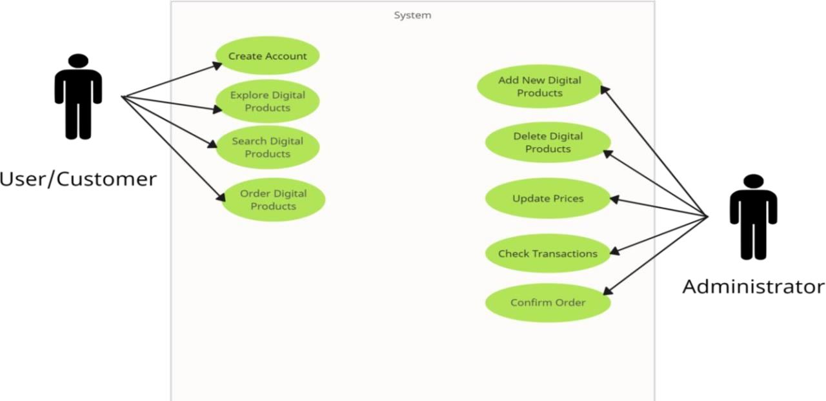

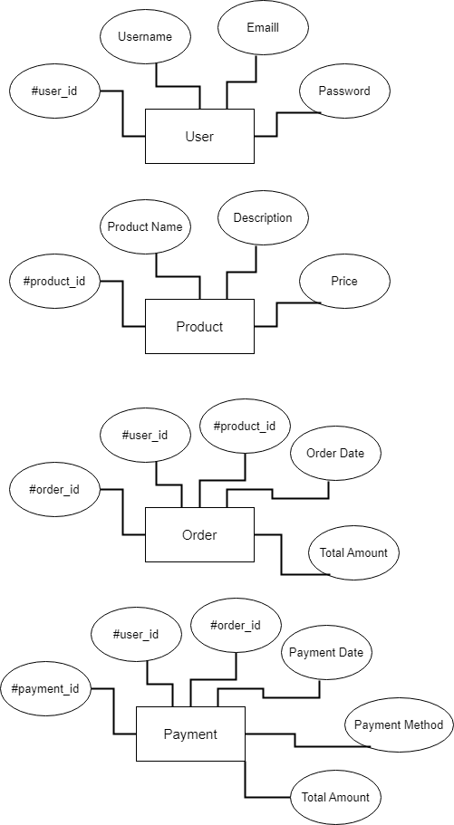

**SCREENSHOTS:**

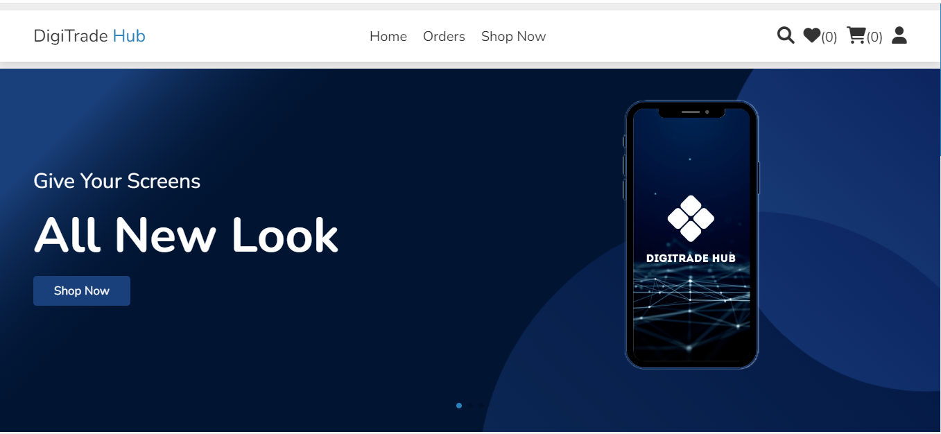





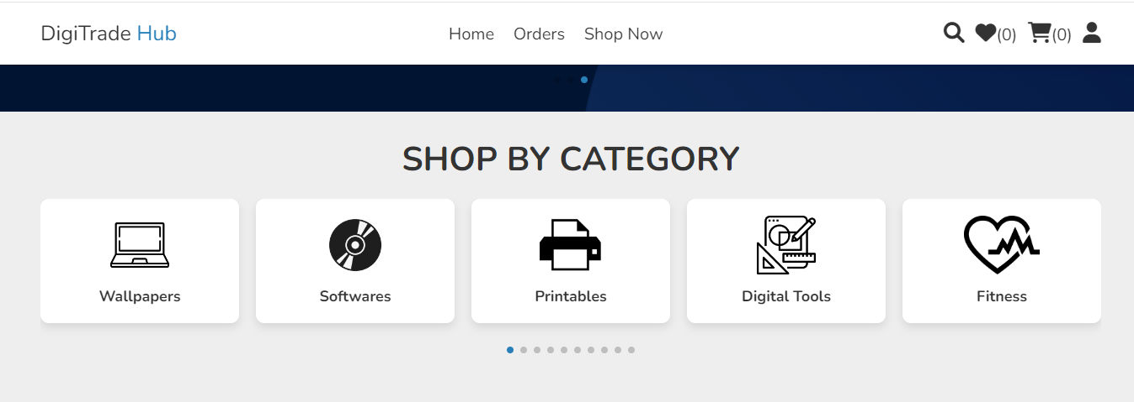

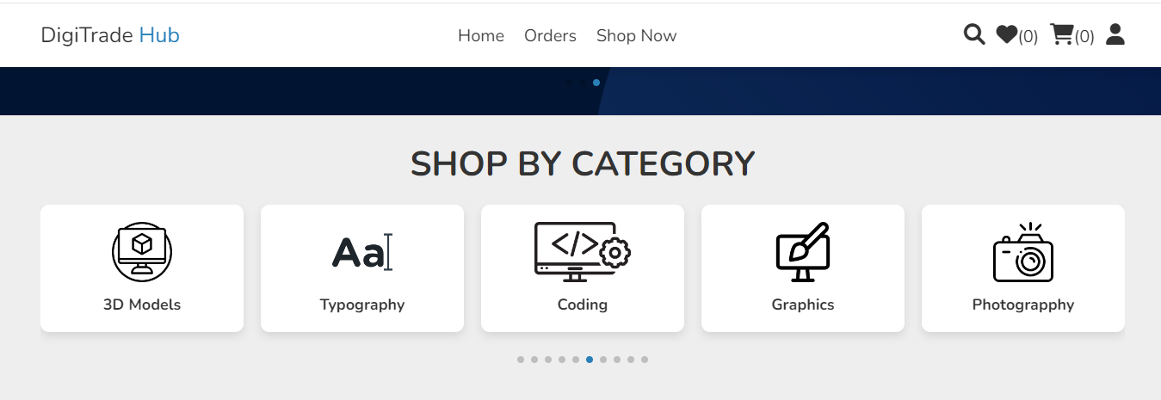

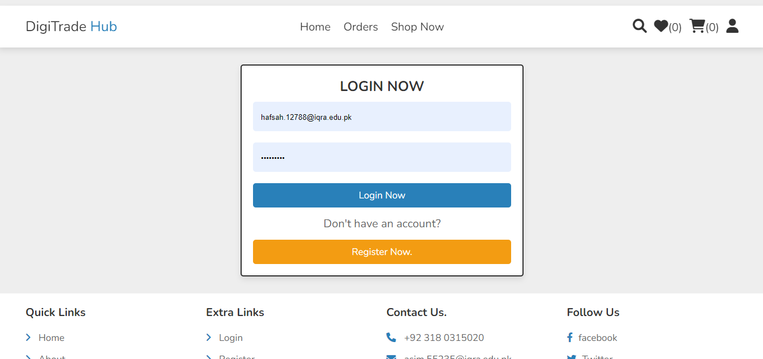

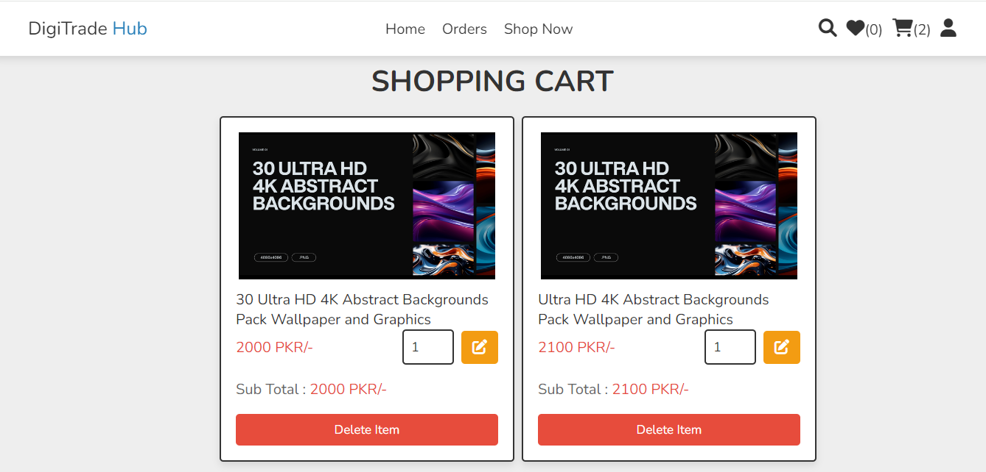

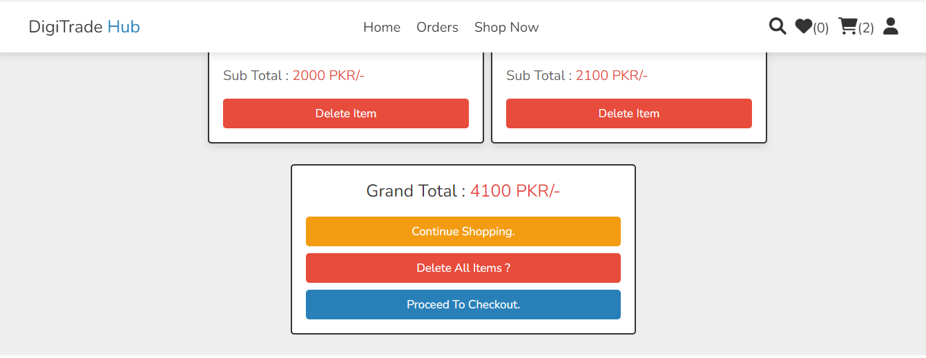

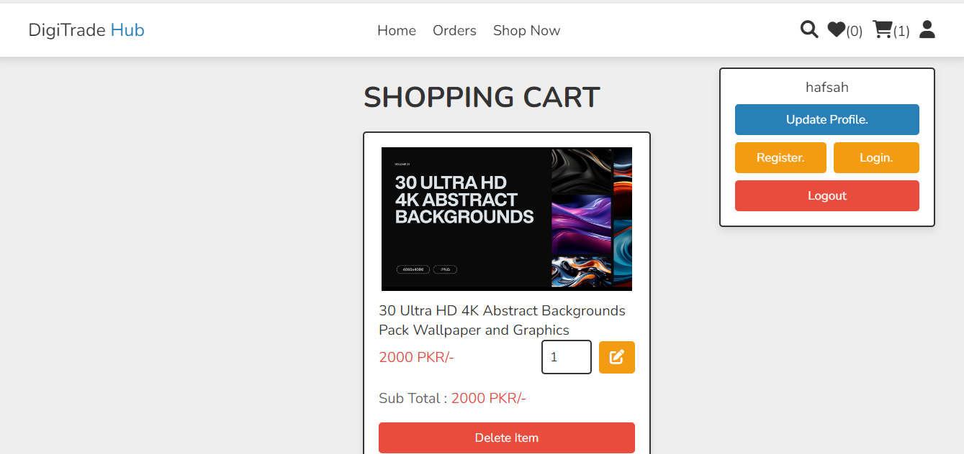

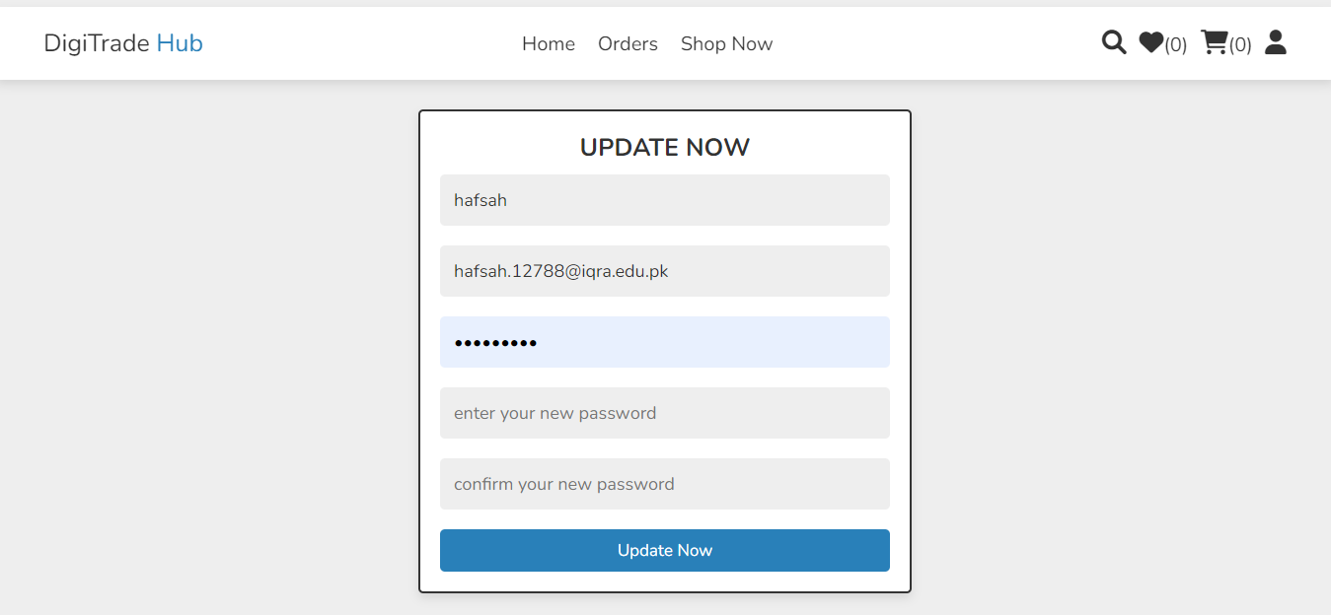

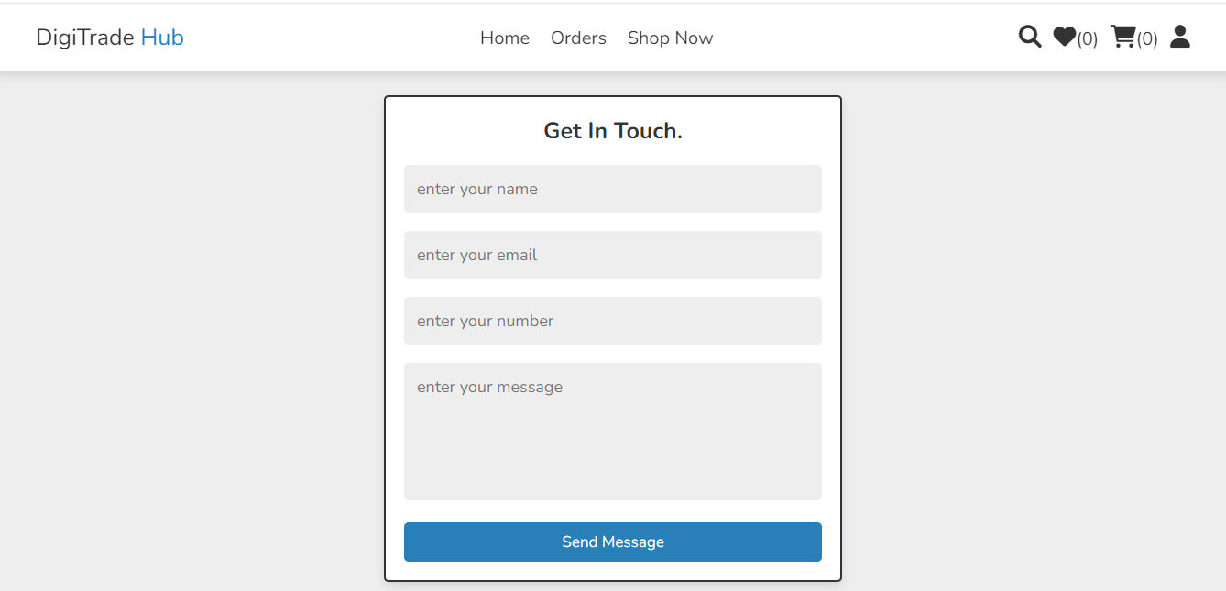

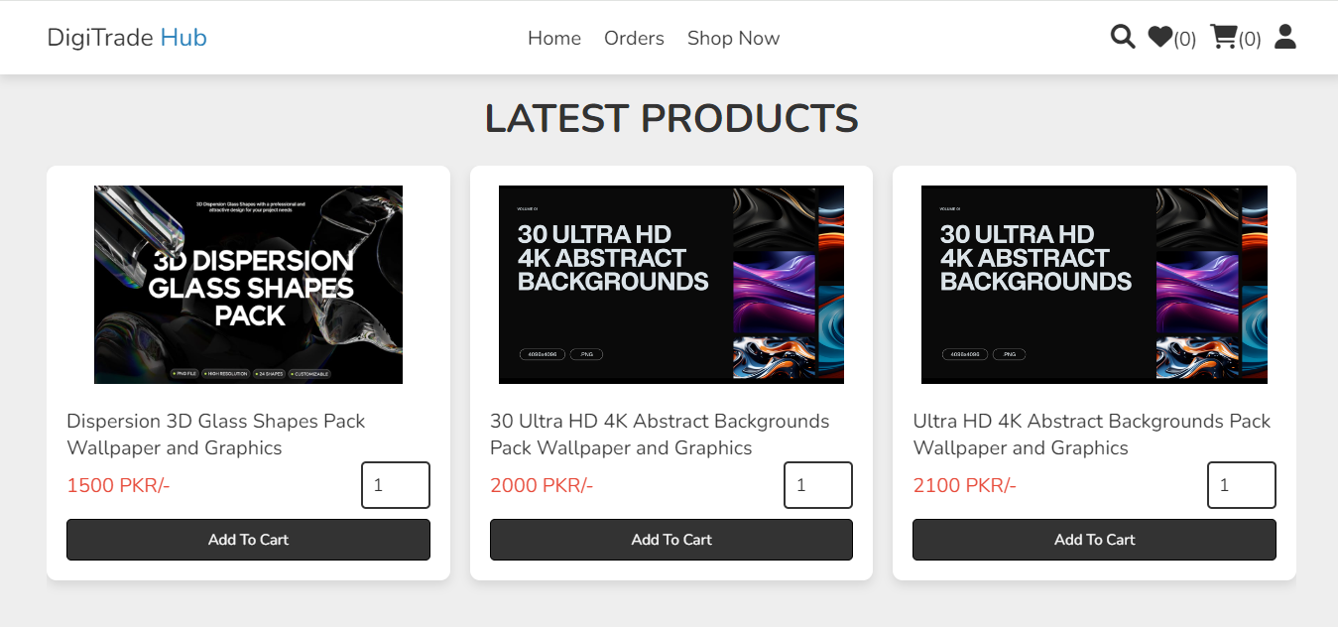

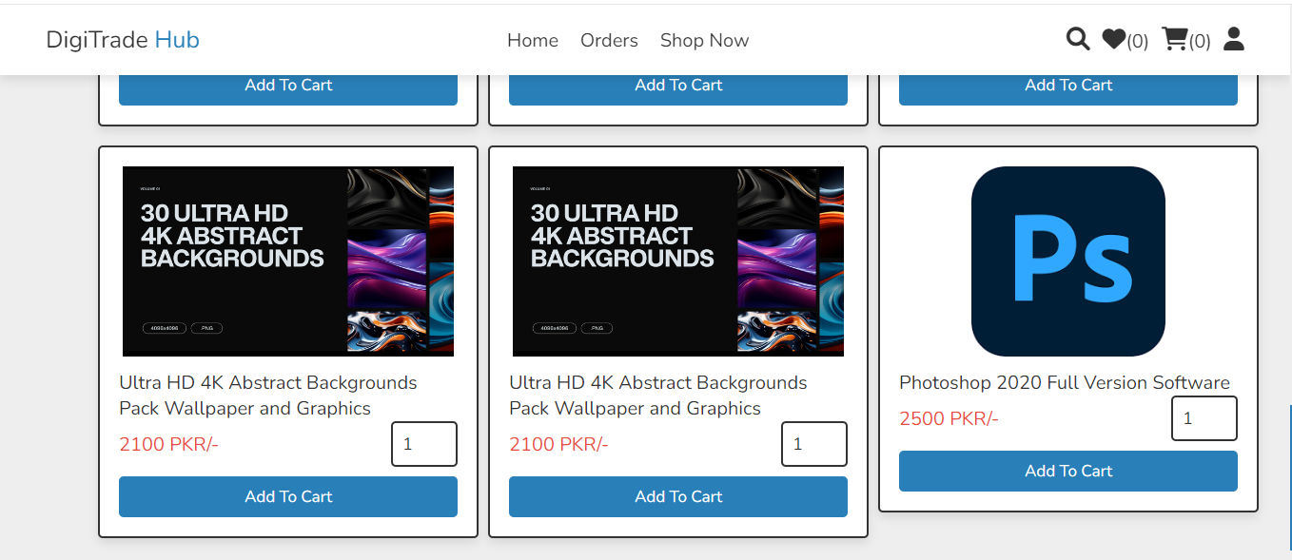

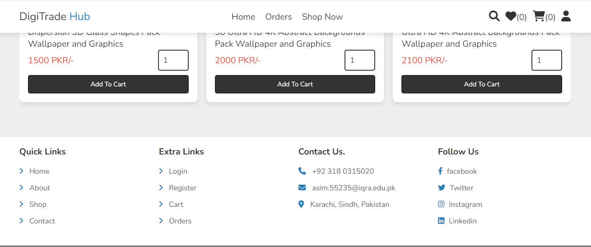

**HOW TO USE AND INSTALL SOFTWARE:**

**Digi-Trade Hub Website**

**Step 1: Access the Website**

* Open a web browser and navigate to the website's URL, such as **http://localhost:3000** or **http://example.com**.

**Step 2: Register or Log In**

* Register for an account or log in to an existing account using the website's registration or login form.

**Step 3: Explore the Website**

* Explore the website's features and functionality, such as:
  + Trading dashboard
  + Market analysis tools
  + News and updates
  + Other features specified in the website's documentation

**Step 4: Use the Website's Features**

* Use the website's features to:
  + Trade digital assets
  + Analyze market trends
  + Stay up-to-date with market news
  + Other activities specified in the website's documentation

**Troubleshooting**

* If you encounter any issues while installing or using the website, refer to the website's documentation or contact the developer for support.

**LINK:**

<https://digitradehub.asmitix.com/home.php>